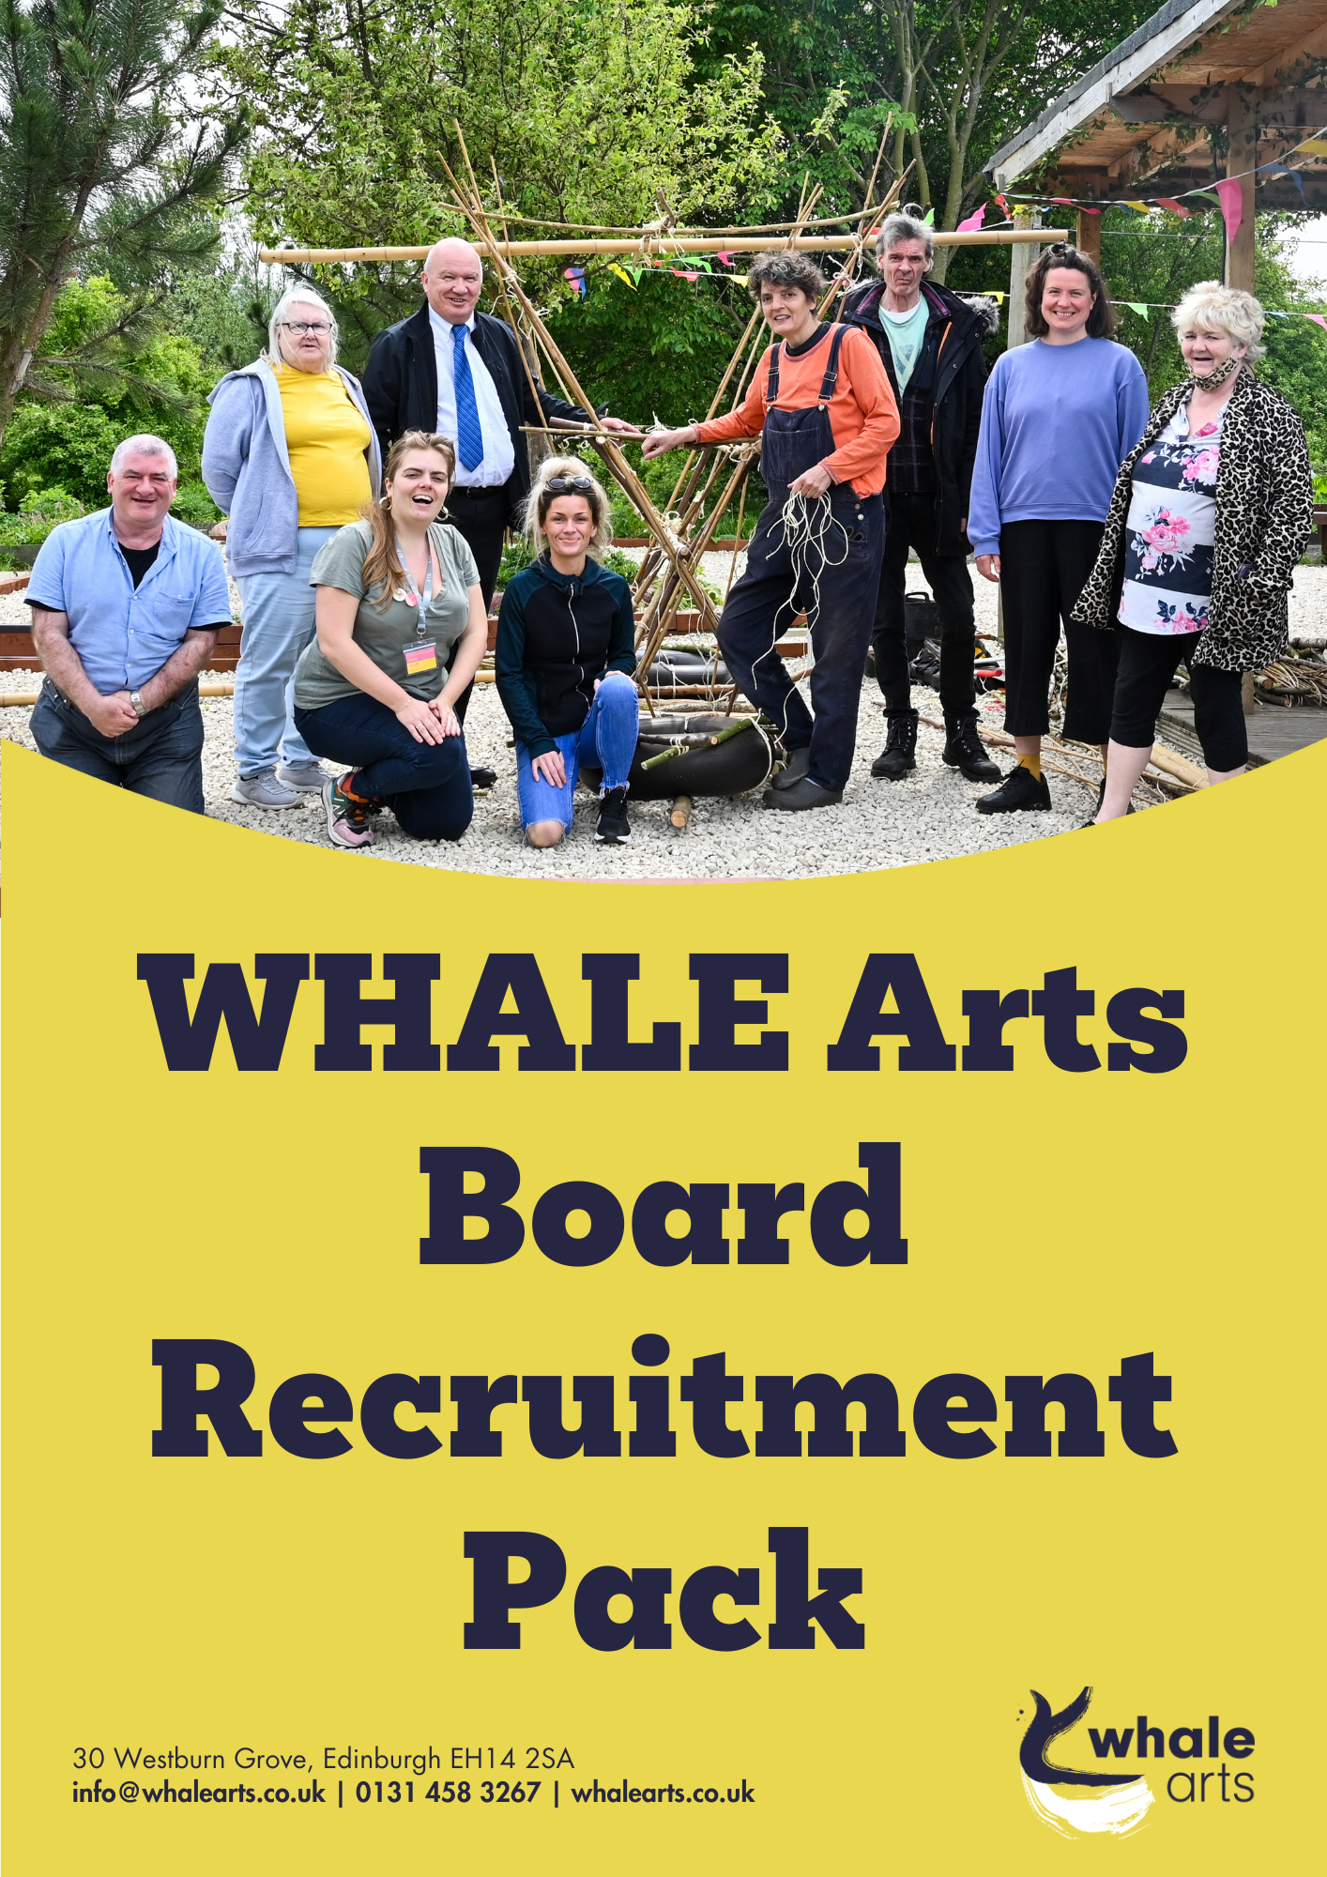
WHALE Arts is seeking new board members from the local community to help shape our work and strengthen our organisation. We are looking for people who care about the arts and creativity, the community and Wester Hailes.
The Board of Trustees
WHALE Arts is a registered Scottish Charity governed by a Board of Trustees who are responsible for setting our strategic direction and maintaining oversight of the smooth running of the charity, supporting the staff team. All charity Boards must:
- do what is best for the charity. They oversee how the organisation is run and make decisions about how money is spent and what are the priorities to deliver.
- make sure the charity does what it is meant to do and follows its constitution and the Charity regulator (OSCR) rules.
- run the charity carefully making sure that the finances, staff, Board, building, health and safety are well managed and follow the law.
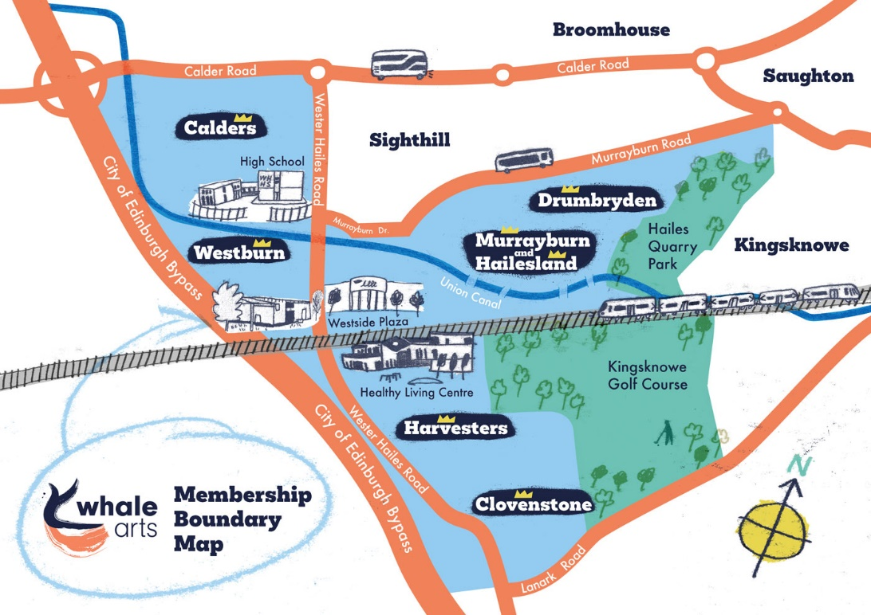
At WHALE Arts, board members fall into two categories: Local board members live within our local membership area (illustrated in the map below). Co-opted board members live outside this area but support our work and bring a particular skills or experience to the board.
The area shown in blue on the map, is our local community boundary for membership purposes.
We are seeking new local board members only at this time.

Joining the WHALE Arts Board
In this round of board recruitment, we are appealing particularly for new local board members who, alongside other skills and expertise, can contribute valuable lived experience and knowledge of the local area.
We are especially interested in hearing from people with skills and experience in:
- knowledge of the local community, understanding the needs, interests and challenges in Wester Hailes.
- Practice as artists (musicians, writers, poets, dancers, performers, directors, painters, sculptors, etc.), designers and makers
- organisational skills like finance, HR, law, community development, building maintenance, IT, marketing, communications.
- supporting people with disabilities/new Scots/vulnerable adults, children and young people.
We know there are lots of ways that someone can gain insight and experience, not just through a professional context. Ensuring that we, as an organisation, have a diversity of voices on our board that represent the views and opinions of our local community is a vital part of our vision and values.
There is no requirement for new board members to have previous board experience. New board members receive an induction and can access training to build their experience.
If you are interested in joining the board but live outside these boundaries, we are still happy to hear from you and may keep your information on file for our next round of board recruitment.
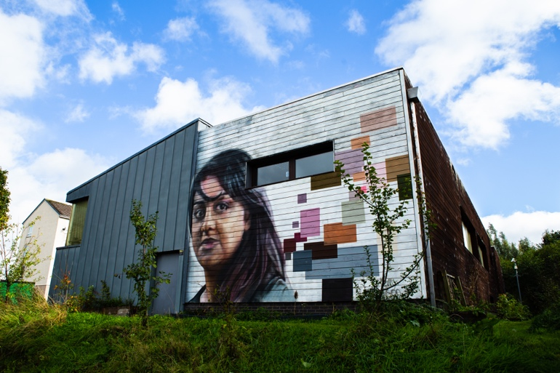

Who can apply?
Anyone can volunteer to be a Board member, regardless of how junior or senior you are in your career, whether you are in paid employment or not, regardless of your ethnicity, class, gender orientation, sexuality or any other difference. Boards thrive on diversity and need a mix of all the different groups within society to deliver robust governance and fulfil our charity’s mission.
Why should I join the board?
Joining the board will give you the opportunity to learn and develop your skills in a supportive environment. You will receive training on running a charity and safeguarding. In turn, both the training and our meetings will give you transferrable professional skills and boost your confidence to support other parts of your community.
We want to make WHALE Arts an inclusive and welcoming community hub for everybody in Wester Hailes. By being part of our board of trustees, you will not only engage with people who share a passion for WHALE Arts but you will help us develop and craft this vision for the benefit of our community for years to come.
What are the tasks for Board Members?
- Prepare for board meetings by reading papers provided in advance.
- Attend Board Meetings and participate in discussions and decision making with the other Board members.
- Share knowledge and experience to support and strengthen our approach to issues and challenges we face.
- Provide strategic leadership to ensure our charitable objectives are met, priorities are established and the staff are supported and enabled in their work for the charity.
- Support the development of the annual plan and budget
- Take responsibility as a Board member to ensure that the board complies with charity, employment, and health and safety law and the charity’s constitution.
- Ensure the financial stability of the charity, its good performance and reputation.
- Ensure the charity has reliable risk management and financial control processes and is able to produce reliable annual accounts

What sort of time commitment are you looking for?
Our meetings take place every two months and last for ninety minutes. Members are asked to come to meetings having read the papers for the meeting ahead of time. Reviewing these documents should take no more than half an hour. It’s important Board Members attend the meetings and our Annual General Meeting for all our members and participants once a year.
What are the meetings like?
The board meet every eight weeks, either in person at WHALE Arts or online. Usually on Thursdays at either 11am or 6.30pm for ninety minutes or less.
Board meetings are structured around an agenda. The agenda and paperwork for each meeting is shared with board members one week before the meeting. We address each agenda point in turn, giving time for board members discuss and ask questions. Some agenda items, such as the approval of new members, will be voted on. The meetings are attended by the Chief Executive of WHALE Arts and led by the Chair of the Board. Sometimes other members of the WHALE Arts team will also attend to share what they have been working on with the board. Tea, coffee and assorted snacks are provided at each meeting.
WHALE Arts operates according to our Strategic Plan, a document that lays out our vision and aims as an organisation over a 5-year period. Over the next 6 months, we will update our Strategic Plan and the board will play a key role in developing our new strategy.
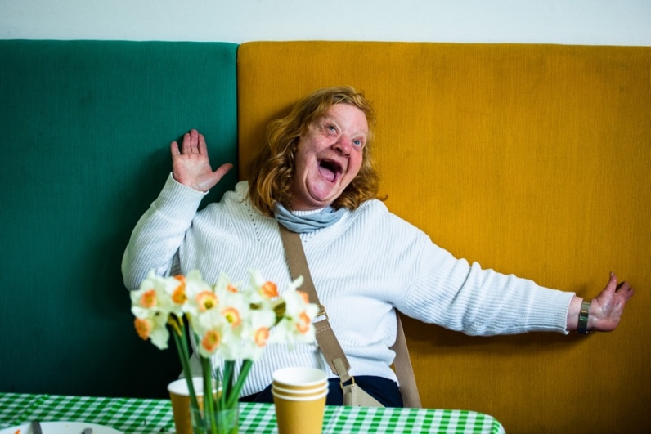

How would I be supported as a Board Member?
Board members are volunteers and are unpaid, but we offer expenses for any access needs, childcare or support or travel expenses if agreed in advance. The full legal framework for the Board of Trustees is in our Memorandum and Articles of Association, which can be provided upon request.
Please talk to us about what would help you to take part – this might be translation (for example if English is not your first language or you would like d/Deaf signing), a support worker (if you need assistance to take part due to disability or health challenges).
We have a minute taker who notes down what happens in the meetings so no-one needs to take notes, but we can provide a scribe if needed. If you would like something else to help you take part, we’d be happy to discuss it with you.
I’ve never been on a board before, can I still apply?
Yes! We recognise that most applicants will not have previous board experience and therefore we will provide training and support to all new board members.
About WHALE Arts
Since being set up 1992, WHALE Arts has become the cultural anchor organisation for Wester Hailes. As a community-led arts charity & social enterprise, WHALE Arts’ mission is to be the creative heart of a vibrant, thriving community.
WHALE Arts acts as a link between the local community and creative opportunities through the direct delivery of projects and events and by working with city-wide and national cultural partners. Our core projects and groups focus on creativity, health and wellbeing for children and adults. We also have targeted groups for adults and young people with disabilities, additional and complex support needs.
We are based in the purpose-built WHALE Arts Centre – ‘The WHALE’ – in Westburn. This is a unique community asset, providing a range of high-quality creative spaces including an Arts Workshop, Performance Space, and Digital Media facilities for our community.
Our currently Strategic Plan (2019-2024) has a focus on Arts, Health & Wellbeing; Creative Placemaking; Enterprise, Learning and Skills as well as Development and Improvement of our building.

WHALE Arts is:
• Community-led
We are embedded in our community; we’re a membership organisation with majority local board members. We consult with local people to inform our work.

• A Cultural Anchor Organisation
We support creative opportunities for local people and work with city-wide and national cultural partners.
• Place-based
We develop creative projects and deliver services that have a focus on people living in Wester Hailes and the social, infrastructural, and economic factors of the area: people and place.
• Building-based
We operate from and run the purpose-built WHALE Arts Centre – ‘The WHALE’ – in Westburn. We are in the process of taking this asset (the building and garden) into community ownership.
• Strengths-based & people centered.
We recognise, celebrate and work to build upon the experience, skills and knowledge of local people and the assets within the community.
. 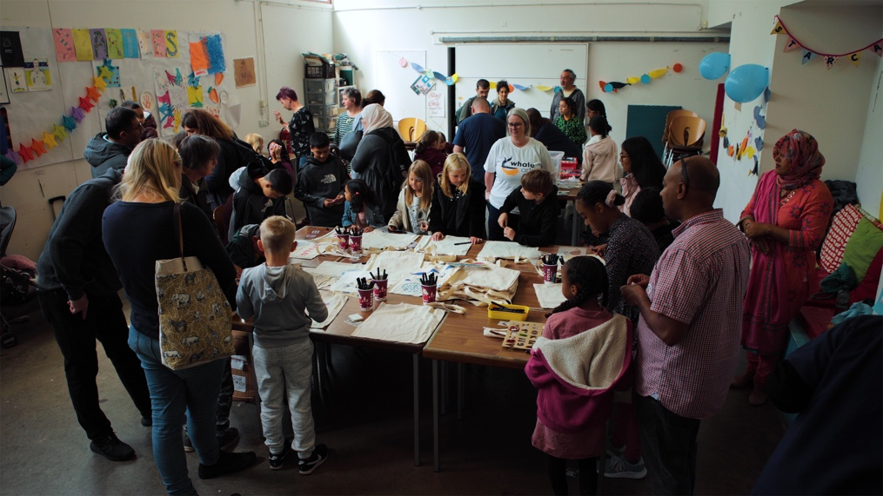

How do I apply?
To apply, please fill out the short form below and either send it to info@whalearts.co.uk or pop in and fill in a paper copy at reception.
Applications from interested individuals should be received by 5pm on Wednesday 6th March 2024.
Please check if you live within our Wester Hailes membership boundary (see area map page 1).
We welcome applications from those protected under the 2010 Equalities Act due to age, gender reassignment, marriage and civil partnership, pregnancy and maternity, race, religion or belief, sex and sexual orientation. If there is anything we can do to make applying for or being part of our Board easier, please let us know and we will do as much as we can to ensure your experience is as equitable as possible.
We want our Board to represent our local community, and we encourage anyone who feels they have something to offer WHALE Arts to get in touch.
If you are interested and have any questions, please contact Kate Griffin at Kate@whalearts.co.uk or 0131 458 3267 who can also put you in touch with a current Trustee.
We are happy to provide information in alternative formats. If you are unable to submit an application by email, please give us a call on 0131 458 3267 to discuss other options.
What happens next?
We’ll contact everyone who applies for a chat with the CEO Kate and/or Board members to see if there is a good fit and to answer any questions.
We’ll invite people who match what we are looking for to come and meet the Board at a meeting or activity. The Board will then vote in new members.
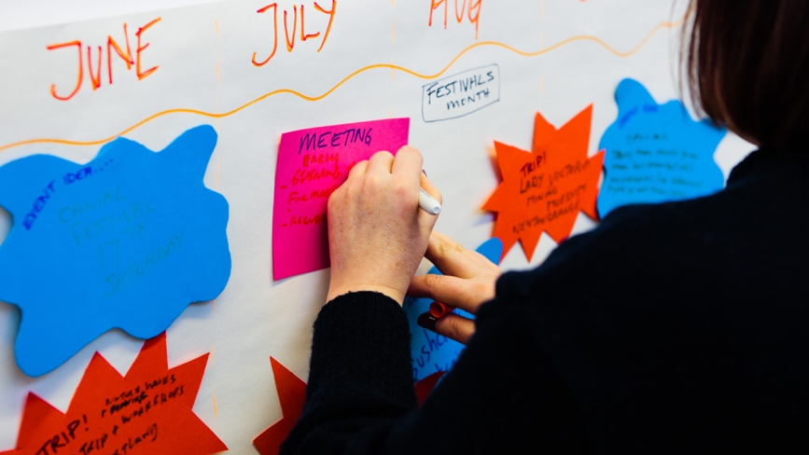
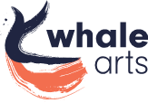
WHALE Arts Board of Trustees – application to become a Board Member
Name
Address
Postcode
Email
Phone
Can you tell us a bit about yourself? How do you spend your time, what are you interested in, what is your connection with WHALE?

Why would you like to join the Board? What can we do to support you and how could you support WHALE Arts - what skills/ knowledge do you have (have a look at the list on page 2 - as a local resident you already have a knowledge of Wester Hailes)?

