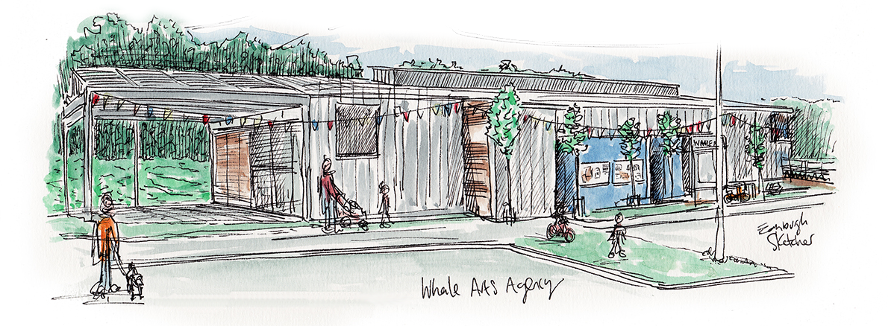
Are you:
Interested in what happens in Wester Hailes?
Do you:
Enjoy meeting and working with people with the same values?
Have 2 hours of your time to spare every 6 weeks?
Enjoy a cup of tea and even a biscuit?
Then we would like you to apply to be a local member of the WHALE Arts Board!
The Board is a diverse group of people who care passionately about what WHALE Arts does and how it can best support the community in Wester Hailes. In order to ensure WHALE Arts is doing a good job we need your views and input.
Call into WHALE Arts for a chat and a copy of our annual report and a copy of the one-page application form or phone 0131 458 3267 or e-mail info@whalearts.co.uk for more information
Deadline: 31st August 2016

